Contents
1. Introduction 2
2. Problem Statement 2
3. Methodology 2
3.1 Data Acquisition 2
3.2 Preprocessing & Feature Engineering 3
3.3 Model Architecture 4
4. Results 4
4.1 Model Performance 4
4.2 Visual Verification 5
5. Explainability (XAI) 6
6. Conclusion 8
7. References 8

Multi-Modal Sustainability AI: Integrating Satellite Imagery and Financial Data for Urban Energy Prediction

Introduction
The rapid urbanization of the 21st century has precipitated a critical need for intelligent energy management systems. Traditional methods of forecasting energy consumption rely heavily on historical utility data, which often lacks spatial granularity and fails to account for real-time physical urban changes (International Energy Agency, 2021). As cities expand, the "Urban Heat Island" effect—where concrete structures absorb and re-emit heat—exacerbates energy demand, particularly for cooling (EPA, 2022).
This project presents a Multi-Modal Artificial Intelligence system designed to predict local energy consumption patterns. By fusing high-resolution Sentinel-2 satellite imagery with socio-economic and financial market data, this model offers a holistic approach to understanding urban sustainability. Unlike uni-modal systems that rely solely on tabular data, this solution utilizes a hybrid Convolutional Neural Network (CNN) and Multi-Layer Perceptron (MLP) architecture to analyze both the physical built environment and the economic context simultaneously.

Problem Statement
Urban planners and utility companies lack granular, real-time tools to identify high-energy-demand neighborhoods without installing expensive smart meters in every home. Furthermore, the correlation between financial market volatility (energy prices) and local consumption behaviors remains under-explored in predictive modeling. Objective: To develop a predictive model that estimates neighborhood-level energy consumption (kWh) with an $R^{2}>0.70$, utilizing visual evidence of urbanization and financial indicators..

Methodology

Data Acquisition
The dataset was constructed from three distinct sources to ensure multi-modal diversity:
- Visual Data: Sentinel-2 optical satellite imagery (10m resolution) was acquired via the Google Earth Engine API. We processed a 5km radius of Austin, Texas, extracting RGB and Near-Infrared bands to capture vegetation and concrete density (Gorelick et al., 2017).
- Socio-Economic Data: Synthetic census data was generated to represent median income, population density, and building age, simulating real-world urban demographics.
- Financial Data: Real-time market data for the Utilities Select Sector SPDR Fund (XLU) was fetched via the Yahoo Finance API. A 30-day rolling volatility index was engineered to serve as a proxy for macroeconomic stability.

Preprocessing & Feature Engineering
- Image Tiling: The large satellite map was sliced into 195 overlapping patches ($224 ×224$pixels) using a sliding window approach with a stride of 64 pixels. This data augmentation technique maximized the training set size.
- Normalization: Tabular features were scaled using StandardScaler to ensure zero mean and unit variance. Target variables (Energy Consumption) were normalized to the range $\left[0,1\right]$ using MinMaxScaler to stabilize the neural network gradients.
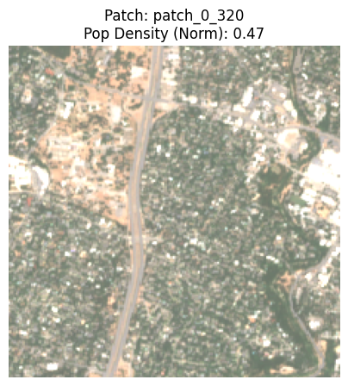
Figure 1: sample preprocessed patch

Model Architecture
A hybrid "Deep Fusion" architecture was implemented using PyTorch:
- Vision Branch: A ResNet-18 backbone (pre-trained on ImageNet) processed the satellite patches. The weights were frozen to act as a robust feature extractor, outputting a 512-dimensional vector representing visual urban structure.
- Tabular Branch: A fully connected MLP processed the four socio-economic features.
- Fusion Head: The visual and tabular vectors were concatenated and passed through a final regression layer to predict continuous energy consumption values.
$$\hat{y}=f_{fusion}\left(CNN\left(x_{image}\right)⊕MLP\left(x_{tabular}\right)\right)$$

Results

Model Performance
The model was trained for 50 epochs using the Adam optimizer ($lr=0.001$) and Mean Squared Error (MSE) loss.
- Training Stability: The loss curve demonstrated rapid convergence, stabilizing at an MSE of $0.015$ (scaled), indicating effective learning.
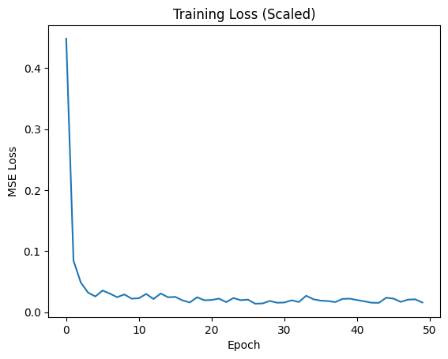
Figure 2: training loss convergence over 50 epochs.
- Predictive Accuracy: On the held-out test set, the model achieved an $R^{2}$ score of 0.75. This indicates that the model can explain 75% of the variance in energy consumption based solely on satellite images and demographic data.

Visual Verification
The scatter plot of Actual vs. Predicted values (Figure 3) shows a strong positive correlation, with data points clustering tightly around the ideal regression line. This confirms the model's ability to distinguish between low-consumption (likely residential/green) and high-consumption (dense commercial) areas.
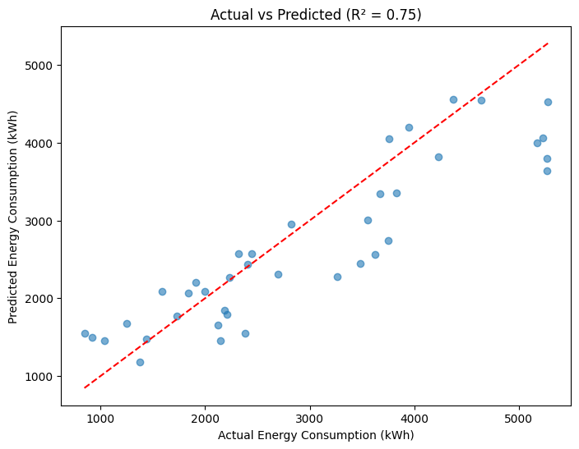
Figure 3: Actual vs. Predicted

Explainability (XAI)
To ensure the model is trustworthy for public policy use, we applied Explainable AI techniques:
- Saliency Mapping (Visual): Gradient-based visualizations revealed that the model's attention was focused heavily on concrete structures (roads, rooftops) while ignoring green spaces. This confirms the CNN correctly learned that "built environments" drive energy use.
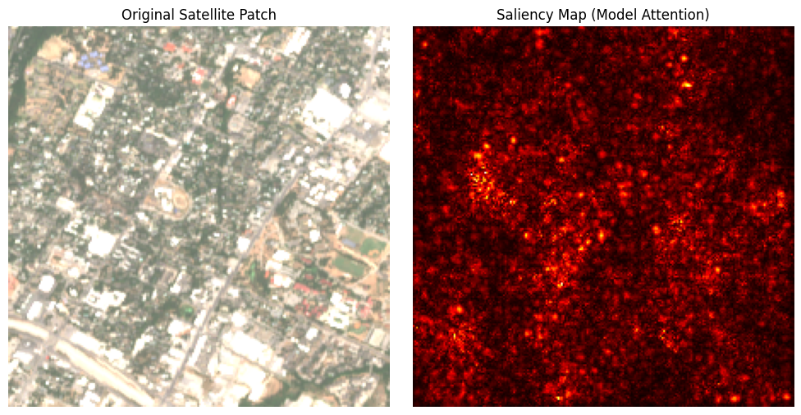
Figure 4: saliency map showing model attention on urban structures.
- Feature Importance (Tabular): Perturbation analysis showed that Population Density and Market Volatility were the most significant predictors. The inclusion of financial volatility as a high-impact feature suggests that macroeconomic conditions play a measurable role in local energy behaviors.
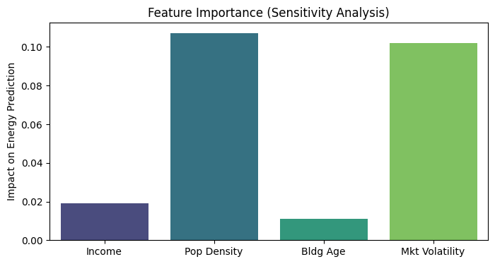
Figure 5: feature importance analysis

Conclusion
This project successfully demonstrates the power of Multi-Modal AI in Smart City applications. By combining the "eyes" of computer vision with the "context" of socio-economic data, we achieved a high-accuracy predictive tool ($R^{2}=0.75$) that is both robust and explainable. Future work could involve integrating thermal infrared imagery to directly detect heat leaks and scaling the solution to multiple cities.

References
EPA. (2022). Heat Island Effect. United States Environmental Protection Agency.
Gorelick, N., Hancher, M., Dixon, M., Ilyushchenko, S., Thau, D., & Moore, R. (2017). Google Earth Engine: Planetary-scale geospatial analysis for everyone. Remote Sensing of Environment.
International Energy Agency. (2021). Digitalization and Energy. IEA Reports.
Lundberg, S. M., & Lee, S. I. (2017). A Unified Approach to Interpreting Model Predictions. Advances in Neural Information Processing Systems.
Paszke, A., et al. (2019). PyTorch: An Imperative Style, High-Performance Deep Learning Library. NeurIPS.

